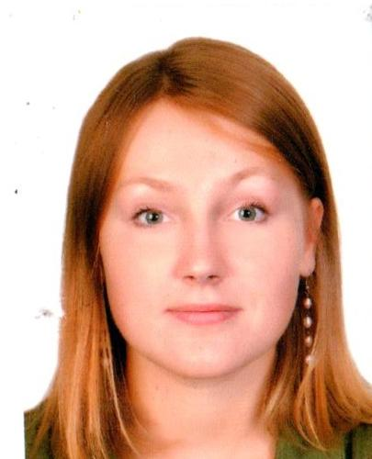 |  | Varvara Bahachova  Female, 24 years, born on 11 May 1994  +375 (29) 8658098  warenitchek@gmail.com — preferred means of communication  Skype: warenitchek17  Reside in: Minsk, m. Partizanskaya  Citizenship: Belarus, work permit at: Belarus  Ready to relocate, ready for business trips
Desired position and salary
Assistant to the Head of Mission

Employment: full time
Work schedule: flexible schedule
travel time to work: any
Work experience — 3 years 4 months
October 2017 — till now  1 year 2 months |  | NGO «Bahna»  Minsk, bahna.land/  Volunteer-translator  Translation of international correspondence and informational articles for the website.
August 2017 — till now  1 year 4 months |  | "Beltechnolologia&M" CJSC  Minsk, beltechnologia.by  Technical translator/Interpreter  Translation of technical documents in the following language pairs: Russian-English, Russian-Spanish, Russian-German, visa, travel and translation support for business trips and during negotiations, business communication and correspondence with foreign customers
October 2016 — till now  2 years 2 months |  | NGO "Belarusian association of social workers"  Belarus, basw-ngo.by/  Volunteer, English teacher, Translator  Teaching English for a group of senior women. Translation of website into Spanish.
February 2018 — April 2018  3 months |  | Forja de Monterrey S.A. de C.V.  forja-mty.com.mx/  Interpreter  Accompanying a team of Belarusian engineers to a factory in Mexico, consecutive interpreting, translation support, translation of documents, software interface etc.
March 2017 — June 2017  4 months |  | "Foreign Languages Center"  Minsk, flc.by/  English and Spanish teacher  Teaching English and Spanish individually and in small groups.
October 2016 — January 2017  4 months |  | SoftCorp PE  Minsk  Translator  Russian to Spanish translator.
May 2015 — September 2015  5 months |  | Realway  Minsk, realway.by/  Spanish teacher  Teaching Spanish individually and in small groups for beginners and intermediate learners
July 2014 — September 2014  3 months |  | Hotel "Sentido Punta del Mar"  www.sentidohotels.com/hotel-search/sentido-punta-del-mar/  Hostess, Assistant Head waiter  Language training on Mallorca island (Spain), working as a receptionist in a 4-star hotel. A certificate from in completing a course in Tourism and Hospitality at Tourism school of Balearic islands. Responsibilities: communication with guests, small errands, filling of database. An excellent speking practice of Spanish, English and German languages.
Education
Bachelor
2017 |  | Belarusian State University, Minsk  Faculty of international relations, International Relations
2016 |  | Universidad de Granada (Spain)  Faculty of Political Sciences and Sociology, Faculty of Translation and Interpretation
Professional development, courses
2014 |  | Swedish language course  Centre of Swedish Studies, Swedish language
2014 |  | Spanish language course at the Tourism school of Balearic islands.  Tourism school of Balearic islands, Spanish language
2013 |  | German language course  MSLU, German languageМГЛУ
Key skills
Languages |  | Russian — native  English — I am a fluent speaker  Belarusian — I am a fluent speaker  Spanish — I am a fluent speaker  German — I can attend an interview  Swedish — basic knowledge
Skills |  | Creativity Communication skills Translation/Interpretaion Spanish English German PC user Language fluency Translation International correspondence Presentations and business meetings
Additional information
About me |  | Fluent English and Spanish speaker, experienced in translating and interpreting for technical and business meetings, NGO’s, websites etc. Translated a book on cross-wedge rolling technology, lots of engineering drawings, technical documentations etc. An excellent team player, punctual, proficient in spoken and written Russian.  Fellowship in Granada (Spain), studying translation and interpretation in Russian-Spanish and English-Spanish language pairs, as well as international relations and political science.  Experience in working abroad (Mexico, Spain, Germany), communicating with foreigners, volunteering for NGO’s, giving presentations and dealing with stressful situations.

