RESUME OF
A K M Muhibul Haque Muhibullah
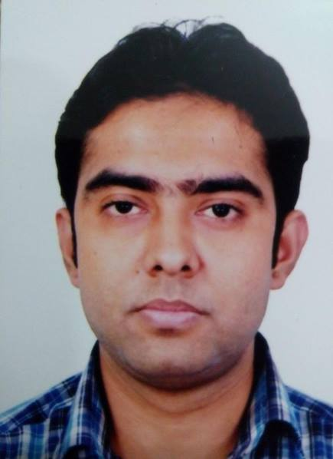
Mailing Address:
A K M Muhibul Haque Muhibullah
Flat-08, House-272/2/B, Road-1st Colony
Majar Road, Mirpur 1, Dhaka-1216.
E-mail: muhib.b4m@gmail.com
Contact # +8801976128150
CareerObjective:

To attain a challenging position in your prestigious organization that will allow me a chance to implement and contribute my education and experiences, by which I can make successful career in the field of Engineering.

Educational Qualification:
Academic Background:

Year  2015 | Name of the degree Achieved  B.Sc In  Computer Science Engineering | Concentration/  Institute  Prime University of Bangladesh | CGPA Obtained  3.25  Out of  4
2009 | Higher Secondary School Certificate (H.S.C) | Govt. Gurudayal College | 3.60  Out Of  5
2007 | Secondary School Certificate  (S.S.C) | Kishoreganj Govt. High School | 4.00  out of  5

Computer Proficiency:
Web Programming & Internet
Web Development & Marketing
Internet Marketing & Freelancing
Computer basic Concept
Operating System Servicing
Networking Setup & Maintenance (LAN & Wi-Fi)

Language Proficiency:
Bengali: - Excellent in Writing, Reading, Speaking, and Lessening.
English: - Good of Writing, Reading, Speaking, and Lessening.

Training Experience:
Name of Course : Redhat Certified Linux
Conducting : Linux Pathshala
Authority Duration : Sever Management, ISP, Networking
Responsibility : Good knowledge
Computer Operating System Servicing,
Hardware Servicing, Printer Setup, & Networking

Training Experience:

Conducting : Daffodil Institute of IT
Course Name : Internet Marketing & Freelancing
Authority Duration : Three Month (01.07.2013 To 05.10.2014)

Job Experience:

Abasaya IT : Internet Marketing
From (01/03/2014 To 01/07/2014)

Linux Pathsala : Network Maintenance
From (01/09/2014 To 01/02/2015 )

Freelancing : Website Development, Affiliate Marketing, SEO Etc .
From (2013 To Still Now)

Learning & : Present (Worked on Project Based From 01/02/2014)
Earning (SDP)

My Skill : Php, MySQL, Html, Css, JavaScript, JQuery, Psd to Html ,Adobe
Photoshop, Responsive Design and Wordpress etc.

Digital Marketing(Facebook Marketing, YouTube Marketing ,
SEO, Affiliate & CPA Marketing , Google & Bing Marketing .)

Project : 1. Affiliate Websites
2. Company Website SEO
3. Social Media Marketing (Facebook)
4. Upwork, PPH, Fiverr

Personal Information:

.
Name : A K M Muhibul Haque Muhibullah
Father’s Name : Late A K M Nurul Haque
Mother’s Name : Mita Haque
Date of Birth : 30/06/1992
Nationality : Bangladeshi
Permanent Address : 528, West Tarapasha, Kishoreganj 2300
E-mail Address : muhib.b4m@gmail.com
Religion : Islam
Nationality : Bangladeshi (By birth)
Sex : Male
Height : 5 Feet 7 Inch
Weight : 65Kg
Mobile No : +8801976128150

Declaration:

I certify that the statement made by me is true, complete and correct.

Reference:

Shibbir Ahmed
Sr. Network Engineer Muhib
Mob No: +8801670557599 Sincerely yours
Email: akm.emdadullah@gmail.com

