Lorna Jane do nascimento Bramley

13 Avenida Professor Bento De Jesus Caraça
Algueirão-Mem Martins, Portugal 2725-127
Mob. No. 936261911 – Email: lorna_bramley@hotmail.com

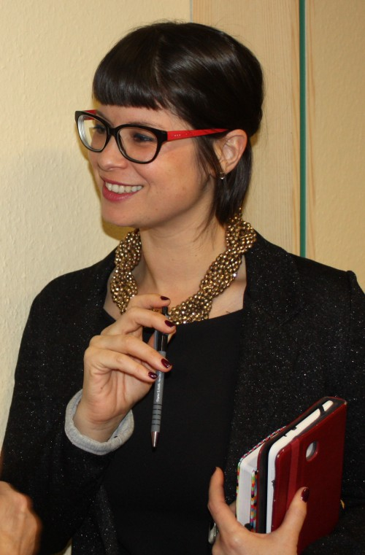

who i am
Language lover, exuberant & positive people-person! Professional a nd enthusiastic, I see translation & interpreting as not just a skill, but a privilege, as it builds bridges between people, cultures, languages, unifying in a divided world. I uphold very strong personal standards & work ethics, a person of my word. I love to learn about other languages, cultures & peoples and teaching is in my blood: 4th generation teacher.
A classical music heritage adds colour to a studious hard-worker, who gives nothing less than 100%.

languages
- English & Portuguese (Native)
- Punjabi (Gurmukhi or Indian Punjabi – fluent speaking, reading & writing)

other languages:
- Portuguese Sign Language (fluent)
- Spanish (fluent speaking, reading & writing)
- Hindi (good understanding & reading skills)
- German (good understanding & reading skills)
- Russian (basic understanding & reading skills)

contact information

Email: translationUKPTPJ@hotmail.com

Proz profile: https://www.proz.com/profile/2544493

Mobile Phone: +351 93 626 1911

Skype: lorna.bramley

Place of birth: London, United Kingdom

Date of birth: 13th August 1980

Currently living in: Lisbon, Portugal

translation/interpreting work experience

Barking & Dagenham Translating & Interpreting Service | London, England
Bilingual Translator & Interpreter - 1998 – 2004
Consecutive and simultaneous interpreting & written translation: Portuguese-English, English-Portuguese & Indian Punjabi proofreading
Senior Administrative Assistant – managing & organizing the work of over 200 translators & interpreters & liaising with local Health Authorities, Legal Institutions, etc- 2000 – 2004

University of Madeira | Madeira – Portugal
Translation of a University Professor’s PhD Thesis – 2004
Market research in the ambit of the Economy of Transportation in Portugal

CEIM (Centro de Empresas & Inovação da Madeira) | Madeira – Portugal
Entrepreneurship Trainer; In-house Translator & Interpreter – 2005 – 2008
Training students from high school to university level (ages 15-23) on “Business Start-up”, creating a business plan & finding niches and entrepreneurial opportunities, etc
Translation of in-house documents relating to a plethora of different business-related projects
Translation of team members’ speech notes for national & international conferences
Simultaneous Interpreter at national & international conferences held by CEIM

International Organization of Jehovah’s Witnesses
Sign Language Interpreter & Portuguese to Punjabi Interpreter (&PJ-PT) – 2008 - 2018
Full-time teacher/interpreter amongst the Portuguese deaf community on the Island of Madeira & the Indian-Punjabi community in Lisbon Portugal
Translated a 5-month Punjabi Language Course Instruction Manual from English to Portuguese

Education
- Mayfield High School, London - United Kingdom
- Liceu Jaime Moniz, Funchal, Madeira – Portugal
- 6 A-levels: History (A), Philosophy (A), Portuguese Literature (A), Techniques of Translation (A), German (A), Latin (B)
- 6-month Russian Language Course – 2006
- 6-month Portuguese Sign Language Course – 2009
- 5-month Hindi Language Course – 2015
- Translating & Interpreting Techniques – Training Course for Bi-lingual Interpreters/Translators – B&D Translating & Interpreting Service – 2003
- Teaching Entrepreneurship from High School to University Level Students – 2005
- 150 Hour Certificate in TEFL – Online Teaching English as a Foreign Language Course - 2018

volunteer work
- 1997 – to present: part of an international Bible-teaching Organization
- 2001 – spent 1 year in rural Bolivia working with the local Quechua/Spanish-speaking community
- 2016 – Assistant Instructor in a 4-month Punjabi Language Course
- 2017 – spent 6 weeks in India (Punjab & Bangalore) working with the local Punjabi speaking community in my volunteer work & improving my spoken, colloquial Punjabi

trANSLATION PROJECTS

Dental Practice's Health & Safety Manual -UK (text) | Medical | Medical: Dentistry | English to Portuguese

PhD Thesis on the Economy of Transportation in Portugal (500 pages) (text) | Social Sciences | Economics | Portuguese to English

Entrepreneurial Opportunities in Portugal - speakers' notes(text) | Bus/Financial | Business/Commerce (general) | Portuguese to English

Novel - Foreword in Portuguese (text) | Art/Literary | Poetry & Literature | English to Portuguese

Translation of English Religious Songs' Lyrics into Panjabi (text) | Art/Literary | Music | English to Panjabi

GP Local Practices' Brochures & Patient Bulletins (text) | Medical | Medical: Health Care | Panjabi

5-month Indian Punjabi Language Course Manual (text) | Social Sciences | Linguistics | English to Portuguese

other texts
Cover letters
Reference letters
Appointment letters (medical, legal, etc)

