Personal information:
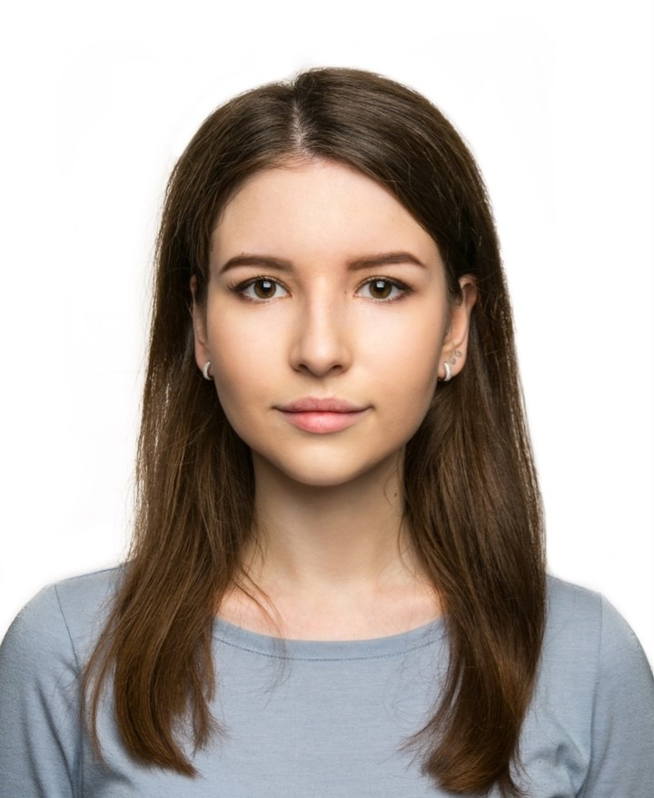
Name & Surname : Aigul Samigullina
Address: Russia, Republic of Tatarstan,
Kazan, Centralnaya St. 104, (420083)
Mobile phone: +79050233082
E-mail: aigulsam2102@gmail.com
Nationality: Russian
Date of birth: 21-02-1997

Education:
Date (from-to): 2015 – present
Kazan Federal University, Institute of International Relations, History and Oriental Studies.
Major: Economy of Asian and African contries (profile: Korean and English languages).

Working Experience:
20 June, 2016 – 18 September, 2016:
Receptionist. Hotel DUNE in Saint-Tropez, France.
1 September, 2017 - 1 June2018:
Teacher. Teaching 14 y.o. girl the English language. Individual lessons. Kazan, Russia.
5 July, 2018 – 12 July, 2018
Interpreter. Expo Center INNOPROM 2018 KOREA PAVILION (Hall 1), Ekaterinburg, Russia.
15 July, 2018 – 25 July. 2018
Teacher. Teaching children (8-13 y.o) the Korean language. Children's camp "Forest Fairy Tale". Cheboksary, Russia.
11 November, 2018 – present
Teacher. Teaching people (11-60 y.o) the English language. “Skyeng” Company. Moscow, Russia.

Skills:
Languages:
English (Fluent), Korean (Good reading and translating ability), French (Good reading and translating ability), Russian (Native).
Computer literacy:
Microsoft Word, PowerPoint, Excel.
Hobbies:
The study of languages, traveling, participation in scientific conferences.
References: available upon request.
Awards:
Exchange program. February 2017- July 2017. Kookmin University, Seoul, South Korea. GPA 4.0
Exchange program. August 2018- January 2019. Shinhan University, Seoul, South Korea. GPA 4.0
Test of Proficiency in Korean (TOPIK), Level 3.
Certificates - available upon request.
Trip: France, Spain, Italy, Germany, Sweden, Finland, Brussels, Warsaw, South Korea.

