CLAUDIA LUBRANO

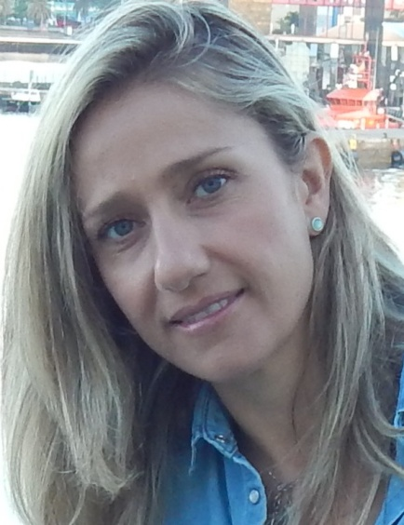

e-mail:claudialubranotranslator@gmail.com
mobile phone: +393756188759
address: Via Aristobulo 23, 00124, Rome
Facebook page: Claudia Lubrano Translator

WORKING EXPERIENCE

May 2016-until now
FREELANCE TRANSLATOR (ESP-ENG-PORT BR>IT; PORT BR>IT-ENG-ESP; ESP>IT-ENG; ENG>IT-ESP; IT>ESP-ENG)
Translations of books, certificates, cover letters, CV, websites (B&B Twenty-seven degrees Las Palmas de Gran Canaria, B&B Casita Boutique Las Palmas de Gran Canaria, QCAD of Andrew Mustun, Impero Couture etc.) Eng>it; It>Eng; Esp>It; It>Esp.
Collaboration with different web agencies (Mr. Wolf Las Palmas, Social Muffin Naples), translation of social media contents. It>Esp; It>Eng.
Collaboration with ATI association for tourism translations Eng>It

September 2015-May 2016:
ACCENT ON LANGUAGE LEARNING (Languages Academy in Las Palmas de Gran Canaria, Spain)
English teacher for children in public schools, official Cambridge exam preparation (KET/PET)

March 2014-June 2015:
LANGUAGE CAMPUS/ENGLISH FIRST(Languages academy in Las Palmas de Gran Canaria, Spain)
English teacher for children in public schools, Italian teacher for Erasmus students.

July-August 2014
INLINGUA LAS PALMAS
Italian teacher for Erasmus students and translator (ESP>IT and vice versa).

February-April 2013
FLAMINGO ENGLISH SCHOOL (English school in Jakarta, Indonesia)
English teacher for children.

May-October 2012
IH RIGA (Latvia)
Italian teacher for adults, English teacher for children and translator (ENG>IT; IT>ENG)
EUROLIVE TECHNOLOGIES
Italian teacher for croupiers online.

December 2011-March 2012
INLINGUA JAKARTA (Indonesia)
English teacher for children in public schools.

April-November 2011
INLINGUA VELLETRI (Rome)
Italian teacher for foreigners, assistant in the office, translator.

December 2006-March 2009
AIR ITALY GROUP (Italy, Poland, Egypt)
Flight attendant on international flights.

December 2005-November 2006
LIVINGSTON
Flight attendant on international flights.

EDUCATION AND QUALIFICATIONS

October 2018-June2019
MASTER IN PROFESSIONAL TRANSLATION: ITA>ENG; ENG>ITA (in law, medical,tourism and web)
SSIT Pescara (Professional Institute for Translators and Interpreters)

October 2011
DEGREE IN FOREIGN LANGUAGES AND LITERATURES TOR VERGATA UNIVERSITY OF ROME

2001
HIGH SCHOOL DIPLOMA, LICEO SCIENTIFICO A.LANDI , Velletri, Rome

LANGUAGES

ITALIAN= native
ENGLISH= excellent
SPANISH= excellent
BRAZILIAN PORTOGUESE= good
FRENCH= basic

ADDITIONAL SKILLS

General IT knowledge (Internet, Office, SDL Trados etc)
Driving license
ATI member 311 (Association Of Interpreters and Translators)

Yours faithfully
Claudia Lubrano

In compliance with the Italian legislative Decree no. 196 dated 30/06/2003, I hereby authorize you to use and process my personal details contained in this document.

