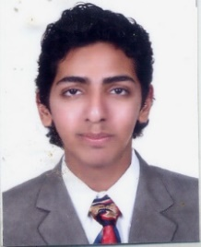
YASHOVARDHAN SHARMA

J-2/5 LABONY SALT LAKE KOL-64, WB, INDIA
PHONE: +91 98300 12900

ABOUT ME
I am decisive, disciplined, charming & extremely cool headed.
I have cleared one of the most competitive exams in the world – SSC CHSL (All India Rank: 1006)

EXPERIENCE
OCTOER 2019 to present
FREELANCE WRITER & CONTENT RESEARCHER AT QUILLCONTENT.COM
FREELANCE WRITER AT ACADEMIA-RESEARCH.COM
FREELANCE WRITER AT WRITINGCREEK.COM

03-10-2018 to 03-06-2019
POSTAL ASSISTANT (SAVINGS BANK CONTROL ORGANIZATION), GOVT. OF INDIA
I have worked as a Central Govt. employee in the role of postal bank audit.

EDUCATION
2007 | Secondary School Exam, CBSE | 78%

2009 | Senior School Certificate Exam, CBSE | 82%

2012 | B.COM (H), Calcutta University | 45%

skills
- Voracious reader. Can spot bad grammar from miles away.
- Great proficiency in English &Hindi. Good Bengali linguist.
- Can Type at 80 W.P.M. easily.
- Adept conversationalist. People of all ages and genders open up very easily.
- Can sell ideas with clarity.
- Can work under immense pressure.
- Excellent knowledge of computers.

HOBBIES
- Incredible singer.
- Dancing.
- Reading
- Playing all sports and indoor games.
- Spending time with nature & animals.
- Interest in technology, politics & films.

