Kerry Ann Justice
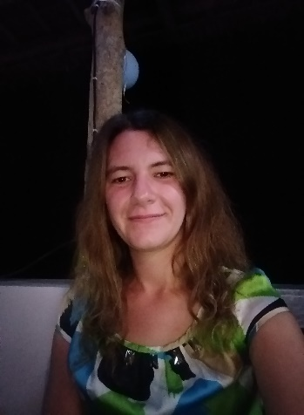
I was born in California, USA, but I mainly grew up in Germany. I was raised bilingual, therefore my native languages are English and German.
I have been doing private translations all my life in various fields: Music, Video Games, Laws, Translations for students in Schools and Universities, etc.
I have also done Data Entry during the time I was employed at a Temporary Employment Agency, as well as having done Annotations on RemoTasks.

Currently I am working for a company at which I am doing Verbatim Transcriptions in German, as well as working as an Assistant Manager for an LLM Project.
Email: kerryjustice91@gmail.com Skype ID: live:.cid.5bf1b66646ac7924
Location: Tablas Island, Philippines
Phone number: +63 966 247 2383
Languages: English and German

Work Experiences
November 2023 – now
Freelancer
- German Verbatim Transcription in the finance and gaming section
- Working on an Entity Project
- Assistant Manager of an LLM Project

May 2023 – November 2023
Freelancer
- Proofreading of German scientific and technical articles for ZAZA Inc.

July 2022 – February 2023
Freelancer
- HT and MTPE of conversational sentences from English to German on Conyac.cc

November 2022 - February 2023
Freelancer
- HT and MTPE of news articles from English to German on Conyac.cc

April 2012 - December 2019
Worker at Mc Donald’s
- Learned all workstations.
- Was sent as representative to all stores in need of extra help.
- Was sent to special events as representative of the store I worked at.

June 2011 - March 2012
Employee at Temporary Time Agency
- Data entry
- Updating data bases
- I placed workers with companies that had job offers

November 2009 - June 2011
Call Center Agent
- Did Customer support for health insurance
- I was responsible for dealing with complaints
- I changed the location and worked for the American embassy, giving out information concerning Visas (I was hired by a time agency)

Education
2009 Highschool Diploma common to south Germany
2001 – 2009 Highschool
1997 – 2001 Gradeschool

