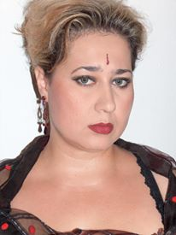 Ada Gur-Karimov

Professional Summary
Dedicated English-Russian-Hebrew translator with years of experience working in professional, scientific and media fields.
Exceptionally accurate translation skills, including simultaneous translation between all parties during teleconferences and in-person meetings.
Diverse translation work including proprietary scientific materials and large-scale executive organization documents.
Consistently relied upon for verification and correction of translated materials.

Skills
Fluent in English-Russian-Hebrew, including colloquialisms, business vocabulary, and scientific terminology.
Experienced with several computer programs, including Microsoft Office, Ace and Translator, and HTML.
Extremely precise and dedicated.
Comfortable with both verbal and written communication, including preparing and giving presentations.
World Wide Customer trainer (Hebrew, English, Russian)
Able to read and understand Turkish and Azerbaijani languages.

Work Experience
- Provide a detailed daily news content for Russian News Portal (English-Russian).
- Provide a daily content for Forex Trading Blog (English-Russian).
- Provide Translations for different restaurant’s menu content (Hebrew-Russian).
- Scientific articles translations (English-Russian, Hebrew-Russian).
- Translation of Manuals and Troubleshooting guides for use by IT personnel (English-Hebrew, English-Russian, Hebrew-Russian).
- Provide Translation of legal documents (Russian-Hebrew), (Russian-English).
- Marketing articles (Russian).
- Copywriting in different fields (Russian).
- Rewriting in different fields (Russian).
- Provide review and verification of translation work as required, including materials created by third-party translation services.
- Delivered 100+ courses and workshops to worldwide customers and business partners.
- Collaborated with cross-functional teams to improve products and support sales efforts.
Hobbies and Interests

Mindfulness Blog Writing.
Voracious reader. Traveler. Enjoy cooking and playing the piano.

adanatural@gmail.com – 054-985-38-22

