 | RESUME
2020 | RAHMAHDI
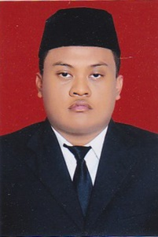 | Indonesia, Riau, Teluk Kuantan  082214098839  adirahm126@gmail.com

BIO
Name : Rahmahdi
Date Of Birth : 02/03/1993
Address : Teluk Kuantan, Riau, Indonesia
PayPal : adirahm126@gmail.com
Prozprofile : http://www.proz.com/profile/2935430
Objectives
Looking for job that related to translation, education, and Human resources
Education
State Islamic University of Sultan Syarif Qasim Riau
2017
Bachelor degree of Education In English Teacher training Major
experience
English teacher & English camp instructor | Mts Baserah & Man 1 Teluk Kuantan
2018 – 2019
Teaching English Language for students on first and second year of Mts Baserah
Teaching English as instructor of English camp for first year of Man 1 Teluk Kuantan
Freelance translator since 2019
skills
- English language proficiency ( speaking and translation focused )
- Teaching
- Microsoft Office
- Translation

