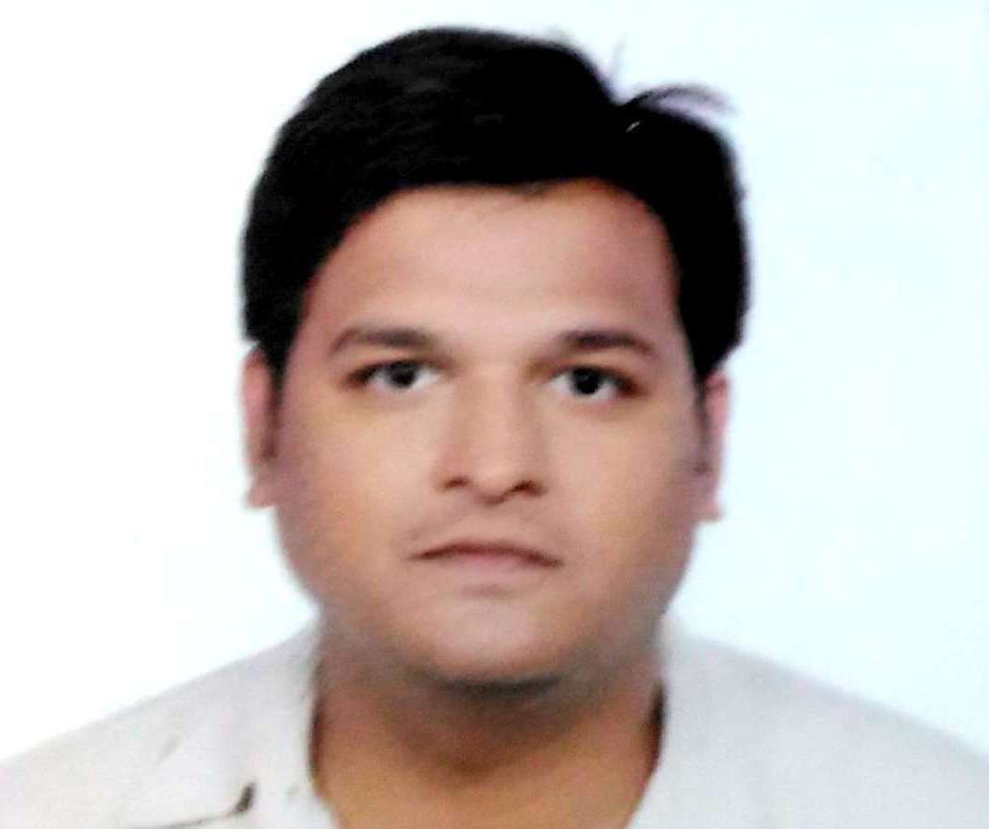
Name: JANMEJAY SINGH

Date of Birth: 15.02.1978

Address:
1. c/o Dr Ramsaran Singh, 388/8 Upen Banerjee Rd, near Airport Main Gate,Parnasree, Kolkata
2. c/o Prof Sadanand Singh, (ex-HOD, Presidency College), kiVill+PO: Kasba,
Block+PS: Shambhuganj, District: Banka, Bihar: 813211

Phone/Mobile: +916232090359 |Email: jansinh@gmail.com

ACADEMIC QUALIFICATION
_____________________________________________________

Secondary

St Lawrence High School (1995), Kolkata, West Bengal Board of Secondary Education

• Passed with 68% marks. Division: 1st

Higher Secondary (Science)

Scottish Church College (1995 – 1998), Kolkata, West Bengal Higher Secondary Council

• Passed with 50.875% marks. Division: 2nd
• In Science stream with Physics, Chemistry, Maths, Biology

Bachelor in Arts (English Honours)

St Paul’s CM College (2001 – 2004), Kolkata, Calcutta University

• Passed with 51% marks. Division 2nd. Class Rank: 2nd
• Political Science and Hindi Literature were additional subjects

PG Diploma in Journalism

Asian College of Journalism (2004 – 2005), Chennai, Media Development Foundation/The Hindu

• Passed one year PG Diploma course in Print Journalism from one of the finest journalism schools in Asia
• Specialised in Identity Politics, Sports writing, Science Reporting, Slum and Deprivation Report

MA in English Studies

Jawaharlal Nehru University (2006 - 2009)

• Passed with CGPA of 5.68 on 9. Division: High Second.
• Passedthe MA course in English from India’s leading central university ranked in top 100 in the world

Ph. D. in Department of English and Other Modern European Languages

Visva-Bharati University (2012-present), Santiniketan

• Admitted to Ph.D. course through Research Eligibility Test (2012) of Visvabharati, a Central University in Santiniketan, West Bengal

WORK EXPERIENCE

CURRENT EMPLOYMENT

Superprof etc.
Freelance Online Tutor for English (March 2020 to Present)

I currently teach an Indian Australian family of three, a UPSC aspirant in Delhi, and a batch of students from KGTM, Bagdogra.
FULL TIME TEACHING EMPLOYMENT

Azim Premji Foundation

Resource Person (Teacher Educator) (June 2018 to February 2020)

• English language specialist for development and facilitation of language learning and language pedagogy courses/TLM and practice exercises, worksheets/audio-visual texts for LSRW skills and strategies of comprehension with prediction, clue spotting, informed guess, global and local meaning making, phonology and phonetics, use of familiar context, fluency, categorisation, practice based self-editing skills for grammar and syntax, vocabulary based on spelling and syllable/prefix-suffix patterns, process writing, coherence and cohesion, translanguaging using multi-lingual skills and basic SOV/SVO syntax etc.
• Chose and took four extensive Internal Capacity Development Training Programmes in English Language and Language Pedagogy Teaching, EVS in Bangalore, Bhopal, Chhattisgarh, Khargone.
• District Coordinator and lead facilitator for English Proficiency Course in batches of 15 each.
with language team for development of content, methods, TLMs for teachers
• Work with block, district and state teams for development of plans for participation on government training programs for teachers at the cluster/block/district/state level.
Develop TLMs, worksheets, short courses for large scale summer and winter camps, sessions, workshops in voluntary and government mandated
• Develop plans for and facilitate workshops, evening discussions, public events, excursion visits, on-site workshops, Balmelas, Balshodh Melas on Language (English and Hindi), perspectives of educatio
• Co-Teach language (English and Hindi) to students from standard I to VIII in five government schools in Khargone and Raibidpura
• Work with Head Teachers and teachers for School Development Plan, print-rich environment, physical environment
• Sole member from Khargone District Institute in national team for Collaborative Design and implementation of content and method on Constitutional values
• Write regular reports, book reviews, reflections

Surendra Pratap Singh Institute of Journalism and Mass Communication, Patna
(Makhanlal Chaturvedi Vishwavidyalay, MP)

Lecturer (June 2012- Feb 2013)

• Teach and evaluate students of Degree, Diploma and Certificate courses in English language, editing, grammar, syntax, cohesion and coherence, report writing, and journalism.

GUEST LECTURER (UGC MANDATED) FOR BA ENGLISH (HONS & GENERAL)

KGT Mahavidyalaya, Bagdogra (North Bengal University)

Guest Lecturer (Feb 2015- Oct 2016)

• Teach and evaluate students of BA English (Hons and General)

Shahid Shashi Prasad Singh Mahavidyalay, Shambhuganj, (Bhagalpur Univ.)

Guest Lecturer (July 2009-May 2012)

• Teach and evaluate students of BA English (Hons and General)

JOURNALISTIC EXPERIENCE
____________________________________________________

New Indian Express, Hyderabad

Sub-editor-cum-Correspondent (March 2005 - October 2005);

• Reporter, editor and page maker on the Feature desk

TEAM LEAD & SOFT SKILLS CORPORATE TRAINING

Cognizant Technology Solutions for CBRE, India, Kolkata

Cluster E-Security Lead, (October 2016 - March 2017);

• Lead the eastern cluster of eSecurity team, Corporate Security from headquarters in
Kolkata
• Manage a team of around twenty Junior and Senior E-Security analysts
• Manage multiple vendors and interact with network and administration teams

OTHER SKILLS
____________________________________________________

Languages & Computer Skills

- I can read and write English and Hindi, speak Bengali, working capacity to read and write Bengali, and read, write and speak Angika, local dialect of Bihar
- Worked extensively in online video streaming

Activities and Affiliations

• Submitted in 2005 Dissertation titled Cricket Writing and the Critical Adversarial under supervision of Late Nirmal Shekhar, Sports Editor, The Hindu and Sportstar
• Attended Summer Workshop of 2019 on Philosophy of Education, Buddhist and Islamic
• Member of Centre Soccer team in JNU
• Active contributor to school and college magazines
• Participated in thriving art, film and theatre scene in JNU campus
• Contributed to the translation of a book by Muzaffar Hussain, 'Islam aurShakahar' from Hindi to English
• Travelled the Western Ghats extensively for slum and deprivation reporting for ACJ

