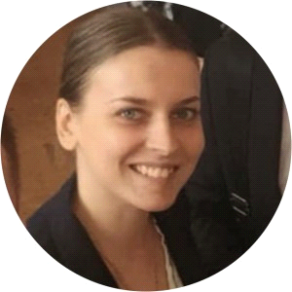
Tatiana Sobala
10.03.1992 Tatiana.so@seznam.cz
České Budějovice (+420) 777 681 619

Education
10.2018 - 6.2021 VŠTE – Ekonomika a management – Business management and economics
9.1999 – 5.2009 Gymnasium No.672 in Moscow – English
Practice
11.2009 - 20.2012 VIOLAIT s.r.o. - Administrative worker / Dispatcher
21.2012 - 25.2014 Clarion Congress Hotel - Receptionist
1.2015 - 12.2016 Family bistro U Sobika - Manager
From 10/10/2018 to now - Self-employed - Translation and interpreting services
Language skills
English - B2
Russian - native speaker
Czech – C2
Driving licence
group B - passenger car
Knowledge and skills
MS Windows XP / Vista / 7, 8, 10, Linux / BSD / Unix, MacOS, MS Windows 7/ 8 / 10
Text editor (MS Word), Spreadsheet (MS Exel), Presentation program (MS PowerPoint), Internet / e-mail, Corel Draw / Adobe Illustrator, Adobe Photoshop, MS Outlook, Viber / WhatsApp, HTML.

