Claire Maria Franklin
UCLan
07484759894 | CMFranklin@uclan.ac.uk | clairefranklin99@gmail.com
https://www.linkedin.com/in/claire-franklin-23211b1b9/
https://www.proz.com/profile/3859294

PROFILE________________________________________________________
A motivated and friendly early-career freelance translator/interpreter based in Northwest England seeking part-time remote work while completing my MA.

I am actively studying and completing translation projects using CAT tools, such as SmartCat, from ENG - KO and KO - ENG. Additionally, as a means of practice and developing my experience, I am actively collating a portfolio with examples of my translation work, as well as writing a translation project for my dissertation. I hope for my portfolio to express my knowledge and competency in translating poems, prose, articles, and academic literature.

I am confident using computer software such as Microsoft Office and Adobe Photoshop. Due to the academic nature of my degree, I have often produced essays, reports, and presentations which have required me to become adept at all manners of Microsoft Office.

EDUCATION____________________________________________________

University of Central Lancashire - MA Interpreting and Translation (Korean Pathway) Present
Pending

University of Central Lancashire - BA (Hons) TESOL with Korean 2:1 2023

Cardinal Newman College - A Level Fine Art, Biology and Chemistry BCD 2020

Parklands High School - 10 GCSEs including English, Maths and Science ABB 2018

WORK EXPERIENCE_____________________________________________
Customer Assistant | Asda, Chorley, Lancs Nov 2021 to Present
Retail
- I am responsible for the general merchandise sector where I maintain and order stock to maximise availability, deal with customer inquiries, and keep the store clean and tidy to fully utilise the appeal of the products.
Work Experience Course | Leyland Trucks, Leyland, Lancs 2016
Engineering
- In this placement, I created CAD design drawings and produced 3D printer prototypes which allowed me to further utilise the software skills I’d previously developed in a different industry.

ADDITIONAL ACHIEVEMENTS___________________________________
- Credited as a translator for the poem ‘Time to lie down and become one with the island’ in the poetry book ‘I Live Alone in Jeju And I’m Weak To Alcohol’ by Lee Wonha (이원하).

- Achieved 3rd place in a Peace Essay competition celebrating 140 Years of Korea-UK Relations. I was awarded with a certificate presented by Ambassador Yeocheol Yoon (윤여철영국 대사) at the Embassy of the Republic of Korea in London, UK.
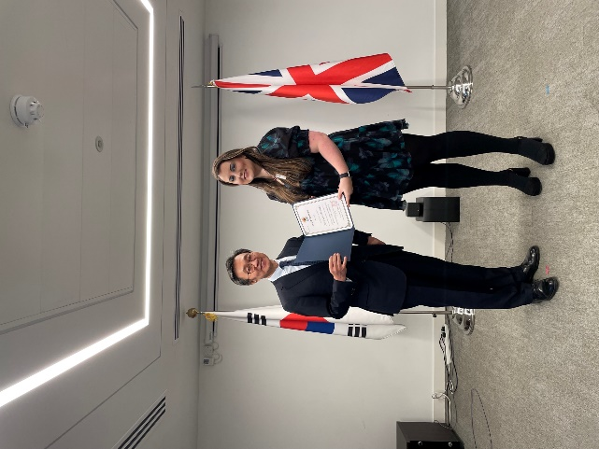

KEY SKILLS____________________________________________________
- Excellent IT skills; confident user of Microsoft Office, CAT tool SmartCAT, and Adobe Photoshop
- Strong communication skills developed through education and frequent interactions with customers in retail.
- Effective team player refined through frequent group work and collaboration in team projects in both BA and MA degrees.
- Well-organised with prominent time management skills; working towards deadlines during a three-year degree, while also being part-time employed, has allowed me to produce nuanced strategies to effectively balance workloads to successfully meet requirements.

INTERESTS_____________________________________________________

- Horse riding has been a lasting hobby and I hope to own rescue horses in the future.

- Travelling; I have visited numerous European countries and have plans to tour East Asia.

- My active presence on social media allows me to follow popular culture and I have a particularly keen interest in console gaming.

- Language learning: I am always seeking to improve and refine my language proficiency and hope to take TOPIK exams to certify my fluency in Korean. I also have an A at GCSE for French and continue self-study for the language.

REFERENCES___________________________________________________

Available on request.

