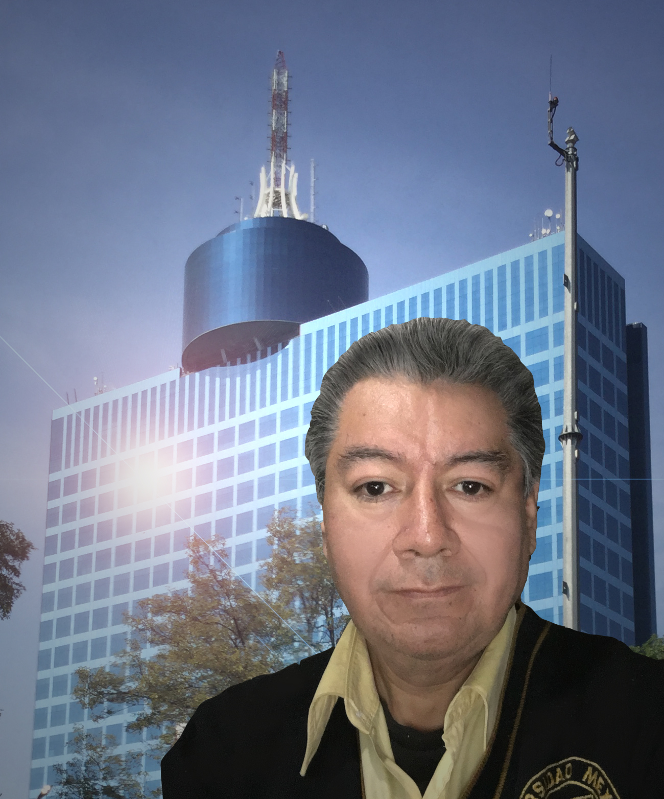Resume of Alejandro M. Mata Acevedo

Over 15 years of experience as an Interpreter-Translator, Subtitler, Voice Over Artist
More than 3,000,000 words translated in last 5 years

Capabilities

Translation English<>Spanish, French>English, French>Spanish, Italian>English, Italian>Spanish
Interpreting English<>Spanish
Voice over English<>Spanish
Subtitling English<>Spanish

Education

CERTIFICATE OF PROFICIENCY IN ENGLISH
THE UNIVERSITY OF CAMBRIDGE, UNITED KINGDOM

BACHELOR’S DEGREE IN INTERPRETING AND TRANSLATION IN ENGLISH AND FRENCH
INSTITUTO SUPERIOR DE INTÉRPRETES Y TRADUCTORES

ENGINEERING DEGREE IN COMPUTER SCIENCES
UNIVERSIDAD AUTÓNOMA METROPOLITANA

Software

Trados Studio 2011, 2015
MemoQ
Aegisub
Subtitle Workshop
Xbench
Microsoft Office
Adobe Photoshop, AfterEffects, Premiere
Dragon Naturally Speaking
Audacity Sound Editor

Other courses

Adobe Photoshop, AfterEffects, Premiere
Diploma in Digital Animation and Video Editing and
Audio Editing with Pro Tools

Contact Information

Email Address: amata2mb@gmail.com
Skype: alejandro.mata56k
Website address: http://alexmata.my.proz.com
Mobile, WhatsApp: (01152 1) 55-1449-0643

Languages

Spanish (Native)
English (Native level)
French (High level)

Sample of projects
IT specific

60,000 word translation for Ericsson about setting up hardware (blade servers, regular servers, terminals), and transaction, management and billing software.
Translation of apps and games for Clifton Chesnut, around 50,000 words.
Marketing specific
Translation for Nokia, all Marketing material for online offers for Mexico between 2008-2013, including translation and transcreation of SMS Marketing Campaign, with restriction to using 8 bit ASCII code and chain length restriction.
Translation for online HSBC Marketing material for Mexico, in Excel spreadsheet, with chain length restriction.
General

Subtitling for Netflix and Franklin Electronics
Translation of the entire English Franklin Electronics website into Spanish
Translation / Localization of user manuals, advertising and user messages for Nokia
Interpreting in October 2008 for training of a professional boxer, Cancun, Mexico
Engineering Interpreting at Pernod Ricard May 2013, Mexico City
Interpreting at Automotive Assembly Factory at Puebla in 2013 (multiple NDA contracts signed, cannot provide name of company)
Quik Draw Voice over of Industrial Videos
Nokia Voice over of Employee Training Videos
Volvo Voice over of Security Features Highlight (Sales)

Recent projects
Interpreting of interviews with Uber drivers, Mexico City, June 13th-17th, 2016. Protected by NDA, no contact data available.
Smartling translation of Marketing, Technical and Operational material for Tesla Motors, April 2017-present. Protected by NDA, no contact data available.
Subtitlling for Novo Nordisk, AT&T, commercial ads
Subtitling for PBS and CBS promos
Subtitling for MTV promos
Subtiling for Internet Marketing e-learning courses

VoiceOver for QuikDraw Industrial Training

References

Name: Giuseppe Falcone Buccella
Company: Black Garlic
Address: Puerto Vallarta #13
Lomas Hipódromo, 22030 Tijuana, B.C.
email: info@blackgarlic.mx

Name: Dan Videki, PMP
Company: Language Request Coordination, Operations
email: <operations@zabtranslation.com>

Name: Julia Ilyukhin
Company: Premium Quality Translation
email: <info@premiumqualitytranslation.com>

Kathy Sprouse | Project Manager
U.S. Translation Company
Kathy@ustranslation.come-mail:
320 W. 200 S.
Third Floor
Salt Lake City, UT 84101
p 801.393.5300 x 111
d 801.456.8670
f 801.393.5500

Kivilcim Parmak
Operations Manager
Avrasya Translations
Gazeteciler Sitesi Hikaye Sk.
Yapıt İş Merkezi No.7 D.5
Esentepe/Şişli/İstanbul-TR
Phone: + 90 444 1994
e_mail : k_parmak@avrasyatranslation.com

János Samu
e-mail: janosS@aol.com
Director
East-West Concepts, Inc.
PO Box 527
Kalaheo, HI 96741
Phone: 808-332-5220 Fax: 808-443-0286
www.eastwestconcepts.com

