Fabiana Paula Margulis
Luis María Drago 354- 5to b (1414)
4855- 9959 / 1562952705-
fabipau@uolsinectis.com.ar/ fabiana_margulis@yahoo.com.ar
msn: fabipau@msn.com, skype: fabiana.margulis
linkedin: ar.linkedin.com/pub/dir/Fabiana/Margulis
webpage: www.traduccionesfm.com.ar/ www.fabianamargulis.com.ar

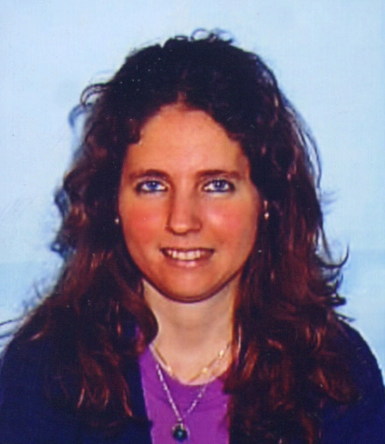

PROFESSIONAL PROFILE

Free-lance translator

-2015-2011: Transcription of audios and translations of letters from Spanish into English and from Hebrew into English/ Translationary Institute. Free-lance translations related to art, medicine, credit card, for specific clients.
- 2012: Interpretation for a group of Mexicans: whispering- about technical matters, architecture, decoration.
- 2010: Sworn translation of the curricula of architecture for a client. Several translations of web pages and contracts, dissertations, personal documents, among others.
- 2009: Translations for private clients and translation agencies.
-2009: Participation in a collective translation project for the web page “ Honoring Life”.
- 2008- 2007: Translations from English to Spanish and Spanish to English for different translators, private clients and for the translation agency École Argentina.
-1999- 1998- 1991: Technical translations from English to Spanish/ Translation of a book of Children Tuina Therapy.

Number of words per day: 2000- 2500 words approximately.
Specializations: legal, literary, scientific, medical, technical, architecture and web page translations, among others.

English teacher to executives in well known companies

- 2010: English classes at IBL to students of Huenei.
- 2009: Helport: Classes of legal English.
- 2008: Allianz S.A., Petrobras, TGV, Helport: classes of legal English.
-2006-2007: Edesur- Telefonica- Alcatel- Techint- Accor- Previsol.
-2003-2004: Río Bank- Itaú Bank- Maersk Sealand- Terminal 4- Safmarine.
-2000-2001: Petroquimica Cuyo. Biosidus. American Express. Sur Argentina.
-1998-2000: Telefonica. Alcatel. Maprimed. Ultimate System. Latin Sport.
-1997: La Plata Cereal. Telefonica. Easy of Escalada. Shell. Waitzman School. Extracurricular programme of English at the UBA. Roemmers Laboratory, Pharmaconsult, Lloyd´s Bank, Union Carbide.
-1993: YPF, Shell.
-1991-1992: Esso Sapa, Hannover Bank.
-1989: Berlitz.

Spanish teacher to foreigners

-2010- 2009: Spanish classes to foreigners at IBL in presence and online (webex). Tour guide. Guided tours for foreigners.
-1997: Australian Embassy.
-1993: I.L.E.E. Institute (students from Filipinas).
-1989-1990: Students from Sweden, Switzerland, Germany, Japan, China, Denmark, Holland, The USA, England, among others.

Architect- Architecture draftswoman

2005- 2004: Thermal and heating equipment fitting out.
2002-1998: Drawing of plans in autocad.

Trips:

-1994: Middle East (Israel, Greece, Egypt, Sinai, Turkey).

STUDIES

University:

- 2013-2011: BACHELOR IN LAW (intermediate university degree in the course of study of law)
-2001- 2008: ENGLISH<>SPANISH SWORN TRANSLATOR (UBA) (graduated in 2008).
- 1984-1992: ARCHITECT (UBA) (graduated in 1992).

Primary and secondary schools:

-1982: Trilingual school (English, Hebrew and Spanish)- Tarbut School

OTHER LANGUAGES

English:

- 1997- 1996: Two- year consecutive and simultaneous interpretation course (The Language School)- Academic certificate of attendance.
- 1970- 1982: Trilingual secondary school (English – Hebrew)

French:

- 2000: 6th year at the French Allianz. Delf Examinations (A1, A2, A3, A4, A5 and A6)

Hebrew:

-1984- 1983: Training in Hebrew Language (13 subjects passed).
-1983: Sequer examinations

COMPUTING

-2010: Basic trados
- 2010- 2009: Webex
-2003: Powerpoint, 3D Studio
-1998: Office (Windows, Excel, Word)
-1997: Autocad 14- M2 Arq.
-1993: Autocad 12

OTHER COURSES AND WORKSHOPS

- 2010- 2009- 2005-2004- 1998- 1970: Artist, painting exhibitions in the CTPCBA, LIF Theatre and Trade Union, Hebraica Club located at Sarmiento St., Province Bank of Avellaneda, French Allianz of Olivos, Jesus P. Martinez School.
- 2002: Micreoentrepreneurships (Ariel Job Center)
-1998: NLP

