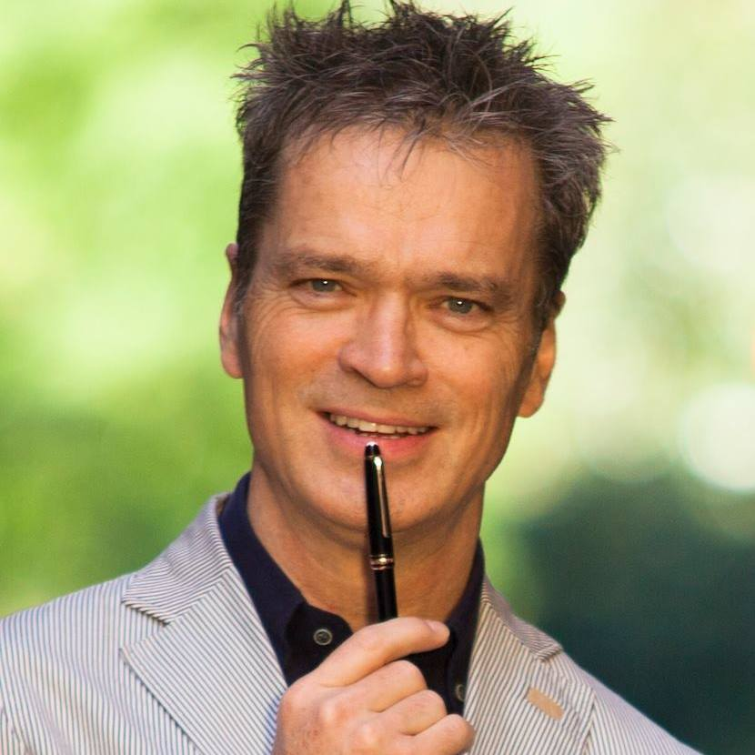

RSA Dip TEFLA, with distinction in both the written and practical exams

Seth Godin’s altMBA intensive digital leadership & management workshop

**1997-98 | University of Exeter, UK**

New York Main Road, NY

+1236 456 785

Team Lead

**ege Name**

M. Ed in teacher training. Distinction

**1991| International School, Istanbul**

**1982-86| Christ Church, Oxford**

BA Honours in Modern Languages

**2018 | altMBA, global**

**EDUCATION**

Change management

contact@andrewmorris.fr

Calle August Font 21, 08035

Barcelona, Spain

+34 689020727

andrewmorristraduction

MORRIS

Leadership

**EXPERTISE**

Communication & Collaboration



**30+ years** of experience in **language teaching and training**, **international education**, journalism, translation, editing and copywriting. Excellent interpersonal, cross-cultural and communication skills based on a **multilingual** and **international** background. Versatile, adaptable, **enthusiastic, results-oriented** **motivator** and **leader** with a clear mission to make a difference and to build a better future.

Training

**PROFESSIONAL EXPERIENCE**

**PROFESSIONAL PROFILE**

Founder and director of a successful boutique translation agency. Responsible for attracting and retaining a wide range of clients, from major museums to airlines, and from international pet food companies to international film festivals. Managed a large team of freelance translators. Also achieved wide recognition within the industry as a leader, blogger and international speaker, presenting at conferences in Chicago, Jerusalem, Lisbon and London. Author of two books on freelance translation.

As Training Coordinator within the ADB TQI project, was responsible for devising and running trainer training and teacher training programs for secondary school teachers. Trained master trainers, ran methodology workshops, managed training teams, and produced the project newsletter.

**LANGUAGES**

English 

French 

Spanish 

German 

Bengali/Chinese/ 

Turkish/Slovak

**Morris Traduction / 2009 – to date**

**DIRECTOR**

**Grontimij / 2016 – 2009: Bangladesh**

**INTERNATIONAL EDUCATION CONSULTANT**

EDUCATOR

LEADER

CHANGEMAKER

**ANDREW**

**FREELANCE EDUCATION CONSULTANT**

* **Positive “can-do” attitude**
* **High self-motivation**
* **Motivating & enthusiastic**
* **Authentic & compassionate**
* **Cooperative & collaborative**



**PERSONAL TRAITS**

**AJ International / 2000-2006**

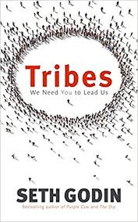

Worked on a large number of short-term training missions worldwide, including Bangladesh, India, Libya, Somaliland, Morocco and Mexico, around communicative teaching methodologies, for agencies such as the **British Council** and **Carl Bro**.

Served as an Inspector on CTEFLA courses and an Examiner on DTEFLA course for **Trinity College London.**

Spoke at international conferences on behalf of **Oxford University Press**, in Zagreb, Hong Kong, Moscow, Cairo and Ljubljana.

Worked for several years as a trainer for **VSO** UK, preparing volunteers in cross-cultural awareness.

**TRAINER OF TEACHERS AND TRAINERS**

**The British Council, Bangladesh / 1998 – 2000**

Devised and delivered methodology courses for teachers and master trainers as part of the **ELTIP** project, introducing more student-centred methodologies both in the classroom and the training room. Set up and ran regional resource centres in Rajshahi and Chittagong.

**ENGLISH TEACHER**

**VSO/Bell Schools British Council/ 1988-1997**

Taught English as a foreign language in several countries around the world:

* China
* Turkey
* Czech Republic
* Eritrea
* Slovakia

Devised and wrote materials and syllabi for special courses. Worked with students aged from 11-18 at secondary schools (Turkey) and a wide range of adult courses on evenings and weekends, offering both general and business English. Worked in extremely low-resource classrooms (Eritrea).

**Community management**

Set up and led several online communities around translation, language learning and personal development

**Entrepreneurship**

Set up and managed two successful freelance businesses

**Professional leadership**

New York Main Road, NY

+1236 456 785

Team Lead

**ege Name**

Achieved international recognition within the translation industry as a thought leader. Wrote a prizewinning guide to successful freelancing

**ACHIEVEMENTS**

* **Languages**
* **Music**
* **Travelling**
* **Culture**
* **Vegetarian food**



**PASSIONS**

**FAVORITE BOOKS**

**MY TIME**